Bc. Jiří Palyza
Business Manager
+420 720 105 218
dynlocktechnology@gmail.com
27.3.20 Coronavirus Protection Products
* Final prices will be confirmed in PO only
# | Product | Photo | Price per unit | Remarks
1 | Disposable Protective Clothing (suit only) | 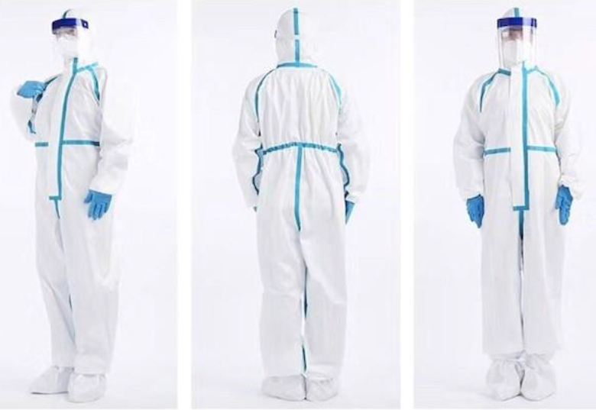 | 26.5 USD | MOQ – 3,000  FOB.  Production rate: 30,000 per day.  50% down payment with PO, 50% with delivery. Price not including VAT.  Source: China
2 | Face Visor | 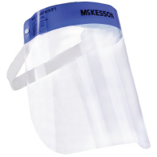 | 3.4 USD | Delivery time 2-3 weeks. Stock ready in the factory. FOB (one factory in China, one in Israel). 50% down payment with PO, 50% with delivery. Price not including VAT.
3 | Goggle | 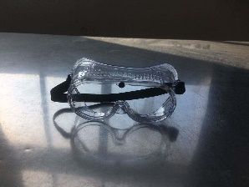 | 5.4 USD | Delivery time 2-3 weeks. Stock ready in the factory. FOB (one factory in China, one in Israel). 50% down payment with PO, 50% with delivery. Price not including VAT.
4 | Respirator FFP2/N95 (Without Valve)  N95 Facemasks with 95% filtration against anti-virus / prevent flu / anti-smoke / dust.  CE Certified.  Ear-loops air-purifying respirator.  Disposable Facemask.  Multi-layer protection with elastic straps. | 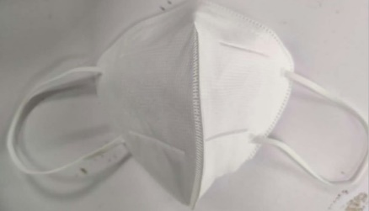 | 3.38 USD | MOQ – 1,000,000.  FOB.  Delivery time: TBD.  50% down payment, 50% with delivery. Price not including VAT.  Source: China
 | Respirator FFP2/N95 (With Valve)  N95 Facemasks with 95% filtration against anti-virus / prevent flu / anti-smoke / dust.  CE Certified.  Ear-loops air-purifying respirator.  Disposable Facemask.  With air filter for easier breathing while wearing a longer time period.  Multi-layer protection with elastic straps. | 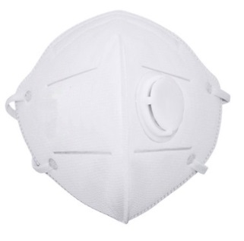  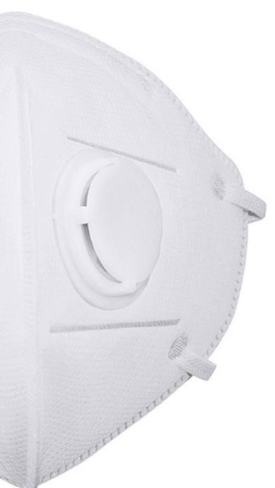 | 3.48 USD | MOQ – 1,000,000.  FOB.  Delivery time: TBD.  50% down payment, 50% with delivery. Price not including VAT.  Source: China
5 | Alco-Gel Hand Sanitizer (300 ML) | 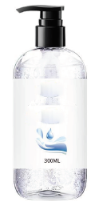 | 5 USD | MOQ -36,000  50% down payment with PO, 50% with delivery.  FOB.  **Flammable – to be considered Sea delivery instead of Air. Price not including VAT.  Source: China
6 | Infrared Thermometer | 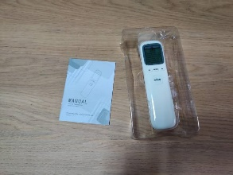 | 78 USD | 300,000 pcs in stock (Changeable).  FOB.  50% down payment with PO, 50% with delivery. Price not including VAT.  Source: China
7 | Protective Suit Type II  (Supervised by the Israeli MoD) | 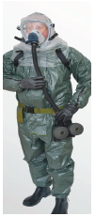 | 462 USD | MOQ – 10,000  FOB.  50% down payment with PO, 50% with delivery. Price not including VAT.  10,000-20,000 units discount 9%  20,000-45,000 units discount 12%.  9% discount from supplier for more than 20,000 units order.  Source: Israel
8 | Protective Gloves (Supervised by the Israeli MoD) | 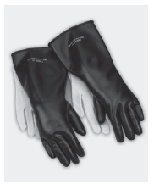 | 45.2 USD | MOQ – 10,000  FOB.  50% down payment with PO, 50% with delivery. Price not including VAT.  10,000-20,000 units discount 9%  20,000-45,000 units discount 12%.  Source: Israel
9 | Protective Boots (Supervised by the Israeli MoD) | 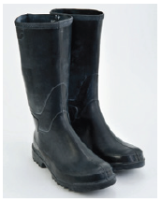 | 42.8 USD | MOQ – 10,000  FOB.  50% down payment with PO, 50% with delivery. Price not including VAT.  10,000-20,000 units discount 9%  20,000-45,000 units discount 12%.  Source: Israel
10 | Protective Overshoes Type II  (Supervised by the Israeli MoD) | 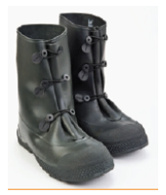 | 82 USD | MOQ – 10,000  FOB.  50% down payment with PO, 50% with delivery. Price not including VAT.  10,000-20,000 units discount 9%  20,000-45,000 units discount 12%.  Source: Israel
11 | Surgical Gloves |  | 9.6 USD  For a box of 50 pairs (100 pcs in one box) | MOQ – 25,000 boxes.  FOB.  7 days ready to deliver. 50% down payment with PO, 50% with delivery. Price not including VAT.  Source: China
12 | Protection Mask with NBC Filters  (Supervised by the Israeli MoD) | 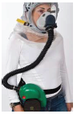 | 784 USD | MOQ – 10,000  FOB.  50% down payment with PO, 50% with delivery. Price not including VAT.  10,000-20,000 units discount 9%  20,000-45,000 units discount 12%.  Source: Israel
13 | COVID-19 test kit  There are 2 models to choose from:  - Antigen = saliva  - Antibody = blood | 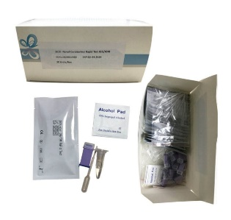 | 8.4 Euros | MOQ – 5,000  FOB.  Production rate: 210K per day.  50% down payment with PO, 50% before delivery. Price not including VAT.  Source: China
14 | Disposable Medical Set | 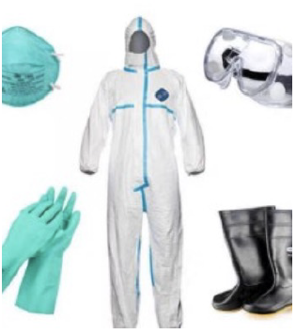 | 106.2 USD | 30,000 units in stock (Changeable).  FOB.  50% down payment with PO, 50% before delivery. Price not including VAT.  Source: China
16 | Surgeon Mask 3-layers | 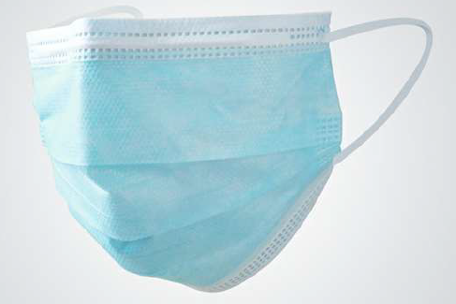 | 0.83 USD  If order 10,000,000  0.52 USD | MOQ – 100,000  FOB.  50% down payment with PO, 50% with delivery. Price not including VAT.  Source: China
17 | Thermometer | 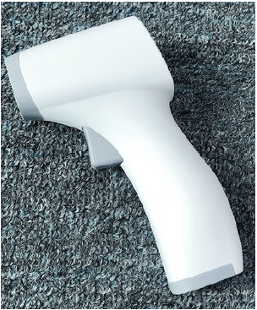 | 129 USD | MOQ – 1,500  FOB.  50% down payment with PO, 50% with delivery. Price not including VAT.  Source: China
18 | Thermometer Port  (A "Plug and Play" device) | 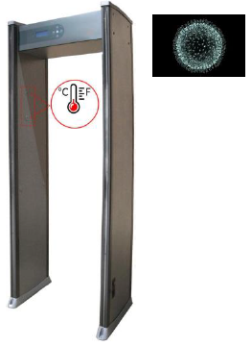 | 3022 USD | MOQ - 5  EXW factory.  FOB for additional 650 USD.  Delivery: TBD.  Warranty: One year.  Production rate: 100 units in 2 weeks, 600 units in 4 weeks.  Source: China
19 | Infrared Thermometer no.2 | 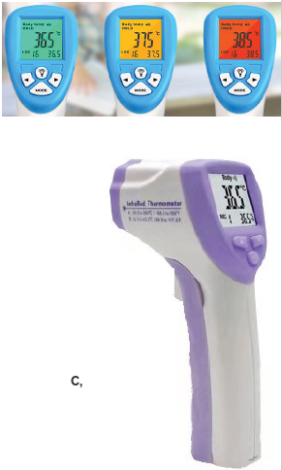 | 73 USD | MOQ – 5,000  FOB.  Production of 5,000 units per day. 50% down payment with PO, 50% with delivery.  Source: China
20 | Medical Critical Care Ventilator | 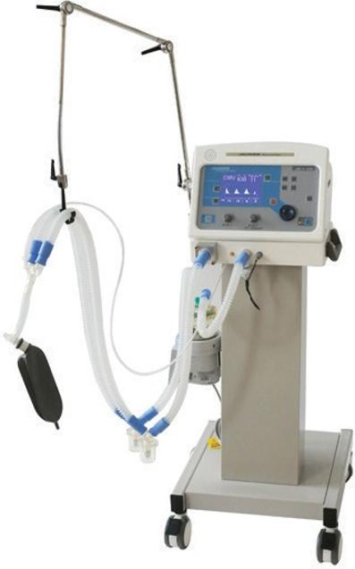 | 39,950 USD | MOQ – 20  FOB.  Production of 50 units per day. 50% down payment with PO, 50% with delivery.  Source: China
21 | Smart Fever Detection Camera | 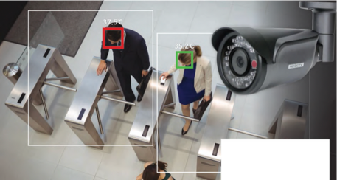 | 2 155 USD | MOQ – 10  FOB.  50% down payment with PO, 50% with delivery.  Source: China
22 | Indoor isolation system - Protection room | 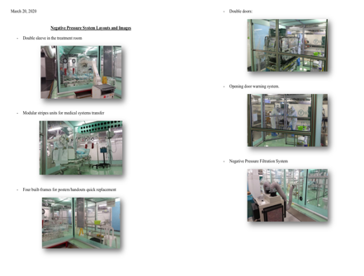 | 485 000 | FOB  Ready till 4 weeks  Source: Israel

**Important notes:
** The quantities and prices are subject to change at any given time due to high demand.
Dyn Lock s.r.o.
IČO: 09049100
Českolipská 400/20, Střížkov, 190 00 Praha

